**1.** In this exercise, we examine in detail how an instruction is executed in a single-cycle datapath. Problems in this exercise refer to a clock cycle in which the processor fetches the following instruction word: **0x00c6ba23**.

1.1 What are the values of the ALU control unit’s inputs for this instruction?

1.2 What is the new PC address after this instruction is executed? Highlight the path through which this value is determined.

1.3 For each mux, show the values of its inputs and outputs during the execution of this instruction. List values that are register outputs at Reg [xn].

1.4 What are the input values for the ALU and the two add units?

1.5 What are the values of all inputs for the register’s unit?

1.1

**0x00c6ba23=** 0000 0000 1100 0110 1011 1010 0010 0011

Opcode 010 0011 -> S-Format

Funct3 011 -> sd instruction

0 1100 -> x12

0110 1->x13

Sd x12 20(x13)

In a sd instruction, the add operation is executed in ALU, so ALU op bit is 00.ALU control lines is 0010.

1.2

Pc+4

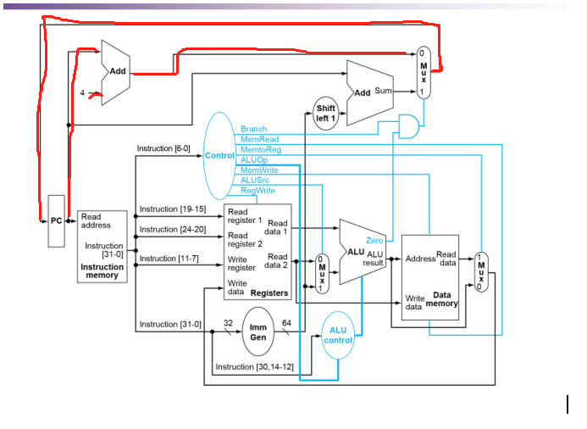

1.3

|  |  |  |  |  |
| --- | --- | --- | --- | --- |
| MUX | Control input | Input1 | Input2 | output |
| ALUsrc | 1 | rs2 | 0x00..014 | 0x0..014 |
| PCsrc | 0 | PC+4 | offs ${sll}_{1}$ | PC+4 |
| MemtoReg |  | rs1+0x..14 | unknown | unknown |

1.4

Since ALU inputs are rs1 and 0x00..014,

Thus, Branch adder inputs: PC and 0x00…028

PC adder inputs: PC and 4

1.5

Read register 1: x13

Read register 2: x11

Write register: null (because Reg Write control signal is disabled for the sd instruction)

**2.**Problems in this exercise assume that the logic blocks used to implement a processor’s datapath have the following latencies:

page2image46084288

“Register read” is the time needed after the rising clock edge for the new register value to appear on the output. This value applies to the PC only. “Register setup” is the amount of time a register’s data input must be stable before the rising edge of the clock. This value applies to both the PC and Register File.

2.1What is the latency of an R-type instruction (i.e., how long must the clock period be to ensure that this instruction works correctly)?

2.2What is the latency of ld? (Check your answer carefully. Many students place extra muxes on the critical path.)

2.3What is the latency of sd? (Check your answer carefully. Many students place extra muxes on the critical path.)

2.4What is the latency of beq?

2.5What is the latency of an I-type instruction?

2.6What is the minimum clock period for this CPU?

2.1

the R-type and I-type instructions both have identical delays (even though the paths are different):

1. PC Register Read delay following rising edge of clock: 30 ps

2. Instruction Memory: 250ps

3. Read Register File: 150ps

4. Mux to pick data from either R2 or sign extended bit data from immediate field of instruction = 25ps

5. ALU delay: 200ps

6. Mux for WB to Register File of result from ALU: 25ps

7. Write back setup time for Register File registers: 20ps

Total = 30 + 250 + 150 + 25 + 200 + 25 + 20 = 700ps

2.2

ld Instruction:

1. PC Register Read delay following rising edge of clock: 30 ps

2. Instruction Memory: 250ps

3. Read Register File: 150 ps

4. Mux to pick data from either R2 or sign extended bit data from immediate field of

instruction = 25 ps

5. ALU delay: 200 ps

6. Read data from Data Mem, whose address provided by ALU: 250 ps

7. Mux for WB to Register File of result from Data Mem: 25 ps

8. Write back setup time for Register File registers: 20 ps

total ld = 950ps

2.3

sd Instruction:

1. PC Register Read delay following rising edge of clock: 30 ps

2. Instruction Memory: 250ps

3. Read Register File: 150 ps

4. Mux to pick data from either R2 or sign extended bit data from

immediate field of instruction = 25 ps

5. ALU delay: 200 ps

6. Write Data from R2 to Data Mem: 250 ps

Total for sd: 905 ps

2.4

beq Instruction:

1. PC Register Read delay following rising edge of clock: 30 ps

2. Instruction Memory: 250ps

3. Read Register File: 150 ps

4. Mux to pick data from either R2 or sign extended bit data from immediate field

of instruction = 25 ps

5. ALU delay: 200 ps

6. Single gate delay AND of ‘zero’ output from ALU and ‘Branch’ control output

from Control unit: 5ps

7. Mux for Branch address to PC: 25 ps

8. Write back setup time for PC register: 20 ps

Total for beq: 705 ps

2.5

I-Type Instruction:

1. PC Register Read delay following rising edge of clock: 30 ps

2. Instruction Memory: 250ps

3. Read Register File: 150 ps

4. Mux to pick data from either R2 or sign extended bit data from immediate

field of instruction = 25 ps

5. ALU delay: 200 ps

6. Mux for WB to Register File of result from ALU: 25 ps

7. Write back setup time for Register File registers: 20 ps

total = 700ps

2.6

Since the minimum clock period = latency of ld, then it is 950ps.

3. (a) Suppose you could build a CPU where the clock cycle time was different for each instruction.

3.a1 What would the speedup of this new CPU be over the CPU presented in Figure 4.21 (in RISC-V text) given the instruction mix below? (assuming instruction latencies from the problem 2)

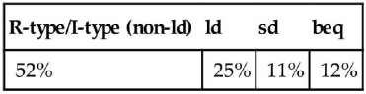

Solution:

Cycle time = 700ps x 0.52 + 950ps x 0.25 + 905ps x 0.11 + 705ps x 0.12 = 785.6ps

Speed-up = 950ps / 785.6 ps = 1.21

3 (b) Consider the addition of a multiplier to the CPU shown in Figure 4.21. This addition will add 300 ps to the latency of the ALU, but will reduce the number of instructions by 5% (because there will no longer be a need to emulate the multiply instruction).

3.b1 What is the clock cycle time with and without this improvement?

3.b2 What is the speedup achieved by adding this improvement?

3.b3 What is the slowest the new ALU can be and still result in improved performance?

Solution:

3.b1

Without improvement: 950ps

With improvement: 1250ps

3.b2

Speedup=950ps/(1-5%)*1250=0.8

3.b.3 Since adding a multiplier unit is insufficient to make up for the 300ps penalty, the new ALU cannot be slower than it that is to result in improved performance.

**3 (c)** When processor designers consider a possible improvement to the processor datapath, the decision usually depends on the cost/performance trade-off. In the following three problems, assume that we are beginning with the datapath from Figure 4.21, the latencies from **Problem 2** in this assignment, and the following costs:

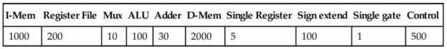

Suppose doubling the number of general-purpose registers from 32 to 64 would reduce the number of ld and sd instruction by 12%, but increase the latency of the register file from 150 ps to 160 ps and double the cost from 200 to 400. (*Use the instruction mix [from 3(a) above] and ignore the other effects on the ISA*)

3.c1 What is the speedup achieved by adding this improvement?

3.c2 Compare the change in performance to the change in cost.

3.c3 Given the cost/performance ratios you just calculated, describe a situation where it makes sense to add more registers and describe a situation where it doesn’t make sense to add more registers.

Solution:

3.c1

Speedup=950ps/(1-12%)*950ps=1.033

3.c2

The original cost=5+1000+200+100+2000+100+500+30*2+3*10+1=3996

New cost=5+1000+400+100+2000+100+500+30*2+3*10+1= 4196

4196/3996=1.05

3.c3

In order to achieve 3% improvement in performance, but cost increase more.So it depends. When the budget is adequate, adding more registers is a better option.

1. ld is the instruction with the longest latency on the CPU from Section 4.4 (in RISC-V text). If we modified ld and sd so that there was no offset (i.e., the address to be loaded from/stored to must be calculated and placed in rs1 before calling ld/sd), then no instruction would use both the ALU and Data memory. This would allow us to reduce the clock cycle time. However, it would also increase the number of instructions, because many ld and sd instructions would need to be replaced with ld/add or sd/add combinations.

4.1 What would the new clock cycle time be?

4.2 Would a program with the instruction mix presented in Problem 2 run faster or slower on this new CPU? By how much? (For simplicity, assume every ld and sd instruction is replaced with a sequence of two instructions.)

4.3 What is the primary factor that influences whether a program will run faster or slower on the new CPU?

4.4 Do you consider the original CPU (as shown in Figure 4.21 of RISC-V text) a better overall design; or do you consider the new CPU a better overall design? Why?

Solution:

4.1

New ld instruction:

1. PC Register Read delay following rising edge of clock: 30 ps

2. Instruction Memory: 250ps

3. Read Register File: 150 ps

4. Mux to pick data from either R2 or sign extended bit data from immediate field of

instruction = 25 ps

5. Read data from Data Mem, whose address provided by ALU: 250 ps

6. Mux for WB to Register File of result from Data Mem: 25 ps

7. Write back setup time for Register File registers: 20 ps

total ld = 750ps

New sd instruction:

1. PC Register Read delay following rising edge of clock: 30 ps

2. Instruction Memory: 250ps

3. Read Register File: 150 ps

4. Mux to pick data from either R2 or sign extended bit data from

immediate field of instruction = 25 ps

5. Write Data from R2 to Data Mem: 250 ps

Total for sd: 705 ps

4.2

Speedup=950ps/1.36*750ps=0.93

Slower

4.3

The frequency of executions of ld/sd.Since ld/sd instructions are the slowest instructions,

4.4

According to 4.3, It depends on how often the ld/sd instructions occur.eliminating the ALU op for ld/sd. however, ld/sd instructions occur more, so it is not a better CPU.

5. (a) Examine the difficulty of adding a proposed lwi.d rd, rs1, rs2 (“Load With Increment”) instruction to RISC-V. Interpretation: Reg[rd]=Mem[Reg[rs1]+Reg[rs2]]

5.a1 Which new functional blocks (if any) do we need for this instruction?

5.a2 Which existing functional blocks (if any) require modification?

5.a3 Which new data paths (if any) do we need for this instruction?

Solution:

5.a1

Since the ALU could be used to add the 2 registers that rs1 and rs2, and the shifter could be used to shift the offset in register rs2. Therefore, there is no new hardware that is needed.

5.a2

The control unit.

5.a3

There are no new data paths needed for this instruction.

6.In this exercise, we examine how pipelining affects the clock cycle time of the processor. Problems in this exercise assume that individual stages of the datapath have the following latencies:

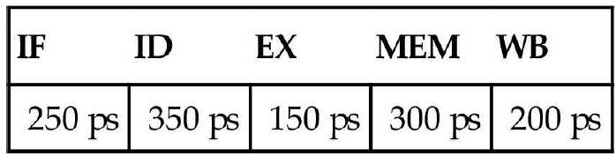

Also, assume that instructions executed by the processor are broken down as follows:

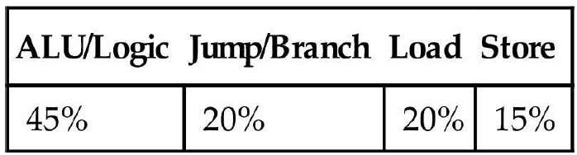

6.1 What is the clock cycle time in a pipelined and non-pipelined processor?

6.2 What is the total latency of an ld instruction in a pipelined and non-pipelined processor?

6.3 If we can split one stage of the pipelined datapath into two new stages, each with half the latency of the original stage, which stage would you split and what is the new clock cycle time of the processor?

6.4 Assuming there are no stalls or hazards, what is the utilization of the data memory?

6.5 Assuming there are no stalls or hazards, what is the utilization of the write-register port of the “Registers” unit?

Solution:

6.1

Pipelined: 350ps

non-pipelined: 1250ps

6.2

non-pipelined: 1250ps

non-pipelined: 1250ps

6.3

The slowest: 350ps

new clock cycle time: 300ps

6.4

35%

6.5

65%

7. What is the minimum number of cycles needed to completely execute n instructions on a CPU with a k stage pipeline? Justify your formula.

k+n-1

For a k stage pipeline ,the first instruction uses k cycles and the rest n-1 instruction use 1 cycle.So the total is k+n-1.

8. (a) Assume that x11 is initialized to 11 and x12 is initialized to 22. Suppose you executed the code below on a version of the pipeline from Section 4.5 that does not handle data hazards (i.e., the programmer is responsible for addressing data hazards by inserting NOP instructions where necessary). What would the final values of registers x13 and x14 be?

addix11, x12, 5

addx13, x11, x12

addix14, x11, 15

Solution:

x13 = 33, x14 = 26

(b) Assume that x11 is initialized to 11 and x12 is initialized to 22. Suppose you executed the code below on a version of the pipeline from Section 4.5 that does not handle data hazards (i.e., the programmer is responsible for addressing data hazards by inserting NOP instructions where necessary).

What would the final values of register x15 be? Assume the register file is written at the beginning of the cycle and read at the end of a cycle. Therefore, an ID stage will return the results of a WB state occurring during the same cycle. See Section 4.7 and Figure 4.51 for details.

addix11, x12, 5

addx13, x11, x12

addix14, x11, 15

addx15, x11, x11

Solution:54

(c) Add NOP instructions to the code below so that it will run correctly on a pipeline that does not handle data hazards.

addix11, x12, 5

addx13, x11, x12

addix14, x11, 15

addx15, x13, x12

Solution:

addix11, x12, 5

NOP

NOP

addx13, x11, x12

addix14, x11, 15

NOP

addx15, x13, x12